**Rhea’s Sourdough Bread**

*This is a recipe for two large sourdough loaves. This recipe uses 75% hydration (medium) and a 30%/70% whole wheat/bread flour mix. It’s delicious!*

**Ingredients**

Sourdough starter/culture (20g)

Whole wheat flour (300g)

Unbleached white bread flour (100g + 700g + extra for handling) *I like the King Arthur brand

Water (100g + 750g + 20g)

Salt (20g)

White rice flour

Poppy seeds or sesame seeds (optional)

Corn meal

**Supplies**

(1) Large mixing bowls

Digital kitchen scale

(1) Plastic containers or jars for starter

Kitchen towels

(2) Proofing baskets (batard shape)

Bread lame or sharp knife

Kitchen brushes

Plastic bread bags or plastic wrap

Pastry/dough scraper

Water bottle sprayer (optional)

**Suggested Schedule**

Day 1:

(evening) Prepare the sourdough starter (levain)

Day 2:

(morning) Mix and prepare the dough

(throughout the day) Let dough rise and perform stretch and folds

(afternoon/evening) Shape the dough and place in fridge for cold proofing

Day 3:

(morning) Add toppings and bake the dough

*For example, I start my starter Friday night and make the dough on Saturday. Then I have bread to bake on Sunday!*

**Day 1 evening: Prepare starter**

1. If you do not have a starter, refer to recipes on making a starter from scratch, or obtain some starter from a bakery.
2. Add 20g of sourdough culture from the fridge or active starter into a plastic container or jar.
3. Add 100g white bread flour.
4. Add 100g lukewarm (70-80°F) water.
5. Stir until all flour is hydrated.
6. Cover with a lid or paper towel. If you use a lid poke a few holes for air exchange.
7. Let sit on the counter overnight or until the starter at least doubles in size. The starter should be very bubbly and smell ripe and active.
8. As you get to know your starter, you will learn when it tends to peak in it’s rise. We want to add the starter to the dough at or around it’s peak. In my kitchen (70-75°F), my starter is ready after an overnight rise (8pm-8am). This time will be different based on your starter and your kitchen temperature.
9. You can test that your starter is ready with the float test. Scoop a small amount of starter out with a spoon and place into a bowl of water. If it floats, there is plenty of air in the starter.
10. If your starter doesn’t grow much or isn’t very bubbly, repeat steps 2-7. Sometimes it will take dormant starters a couple rounds to start back up.

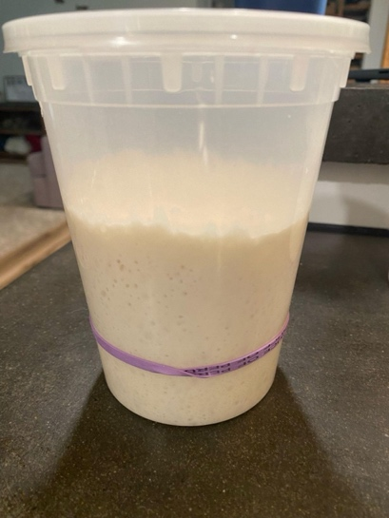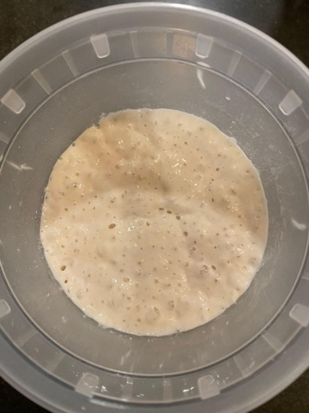

*This is my starter after the rise. You can see it has over doubled (the rubber band marks where it started). The starter is bubbly and ready to use.*

**Day 2 morning: Start the autolyse**

1. Mix 700g of white bread flour and 300g of whole wheat flour in a large mixing bowl. *Be exact in all your measurements!*
2. Add 750g warm (80-90°F) water to the bowl.
3. Mix the flour and water by hand until all flour is hydrated.
4. Once mixed, cover the bowl with a warm damp kitchen towel and leave on the kitchen counter for 1-2 hours.
5. This step gives your gluten a head start and will make the kneading step easier!

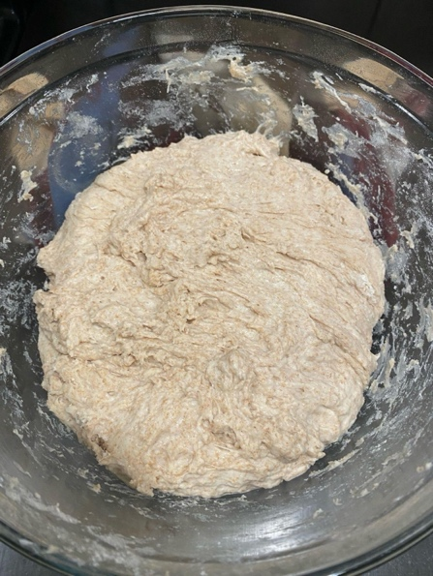

*Here is my mixed flour ready for the autolyse step.*

**Day 2 morning: Mix the dough**

1. Add 200g of starter to the dough and mix by hand until incorporated.
2. Add 20g warm water and 20g salt on to the dough and mix by hand until incorporated. You will notice the dough will be wet at first, and once fully mixed the dough will absorb the moisture.
3. Let sit for 20-30 minutes.
4. Mix the dough by hand for 10-20 minutes by hand. Wet your hand first. To mix, grab one side of the dough and stretch upwards until you feel tension and before it starts to break. Fold over the rest of the dough.

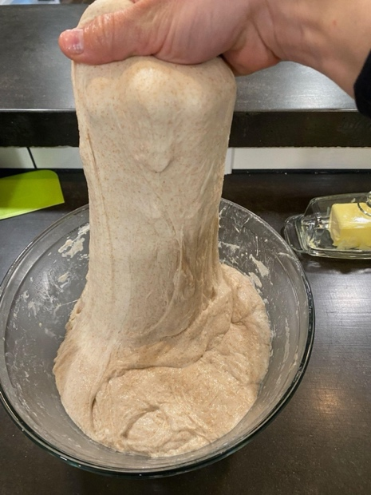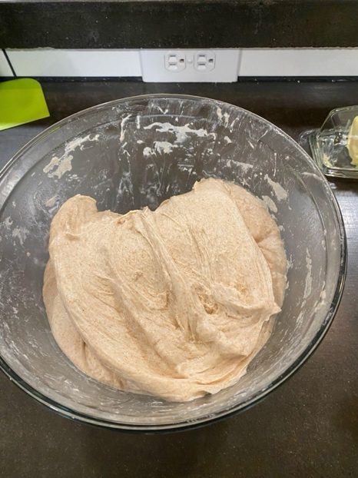

1. Rotate the bowl 90 degrees and repeat this process.

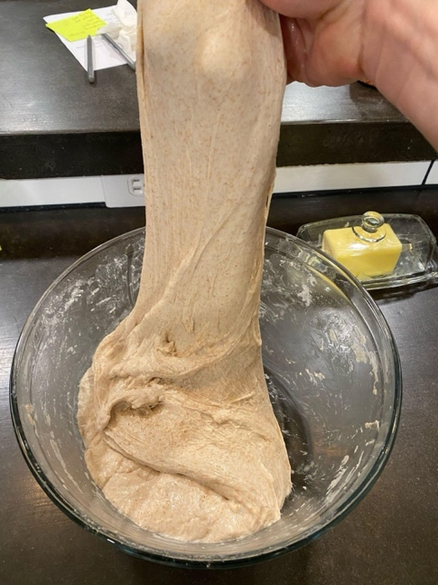

1. Continue rotating, stretching, and folding for 10-20 minutes until enough gluten has developed.
2. To test whether your dough is kneaded enough, perform a window pane test. Wet your hands and grab a golfball sized piece of dough. Stretch the dough with your fingers. The dough should stretch so that you can see light come through the dough without it breaking (right picture). If it breaks before this point (left picture), keep mixing.

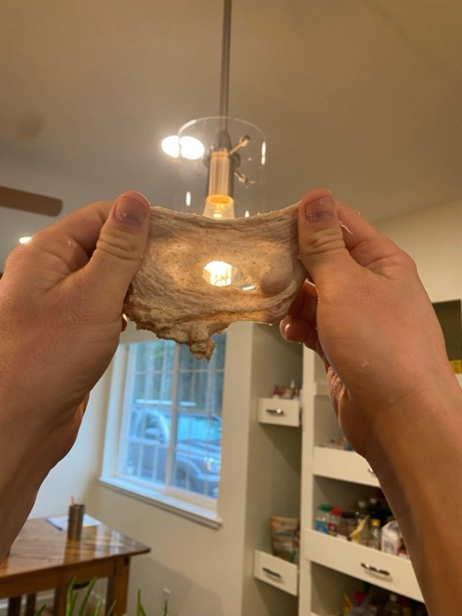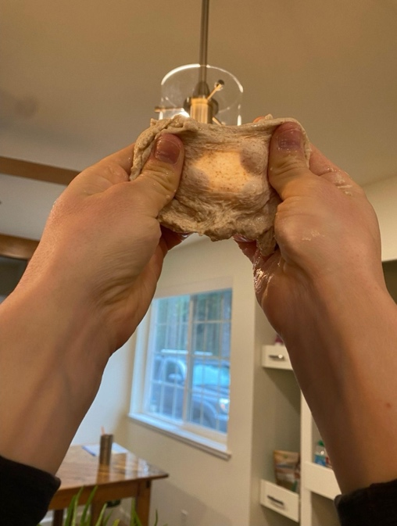

1. If you mix for 20 minutes and the dough is still breaking, you can move on. The bread will still turn out well!
2. Cover with a damp rag and let sit for 30 minutes to 1 hour.

**Day 2 (throughout the day): Bulk fermentation and stretch and folds**

1. After the dough has rested for 30 minutes to 1 hour after mixing, perform your first set of stretch and folds.
2. As done during the mixing step, grab one side of the dough, stretch upwards, and fold over the dough. Rotate the bowl 90 degrees and repeat. Do 8 total stretch and folds (going in a complete rotation of the dough twice).

*Here is a picture of my dough before and after folds.*

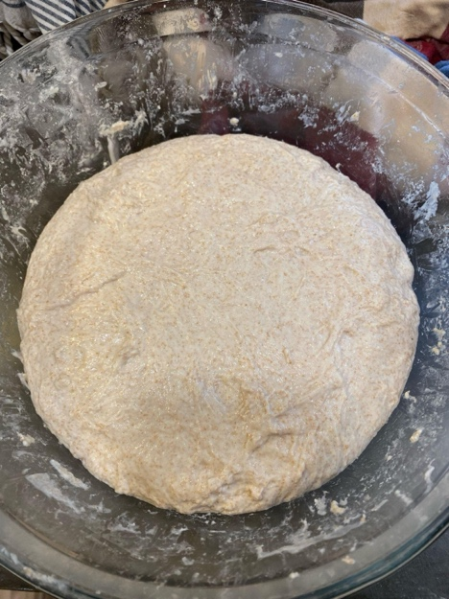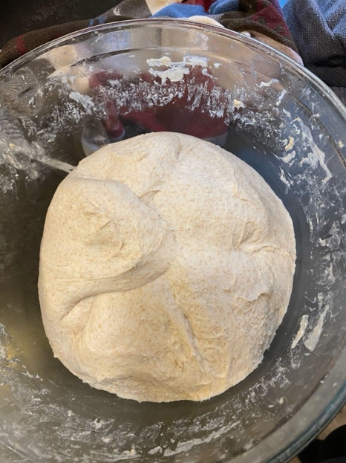

1. Cover again and let rise for 1 hour.
2. After 1 hour, perform another set of stretch and folds, this time only doing 4 folds (one rotation of dough). Cover and let rise.

*Here is what my dough looked like at this step. There are a few surface bubbles.*

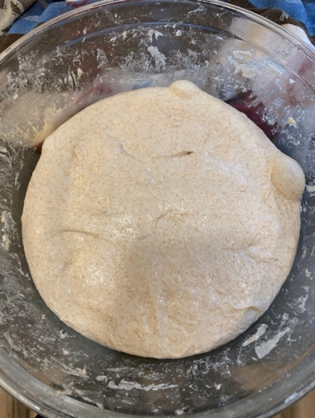

1. From this poi​​nt on, perform a stretch and fold every 1.5-2 hours. As you progress, the dough will become lighter and more airy as it rises. You will need to be increasingly gentle with your dough to not force the air out as you do the stretch and folds.

*Here is my dough after 2 hours. Notice there aren’t many bubbles in the dough yet, but there are a few forming on top.*

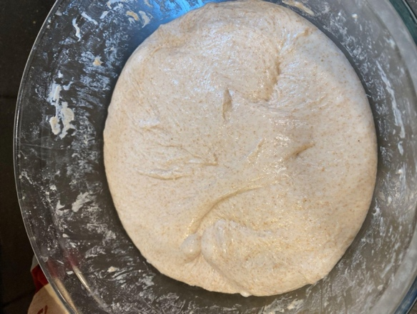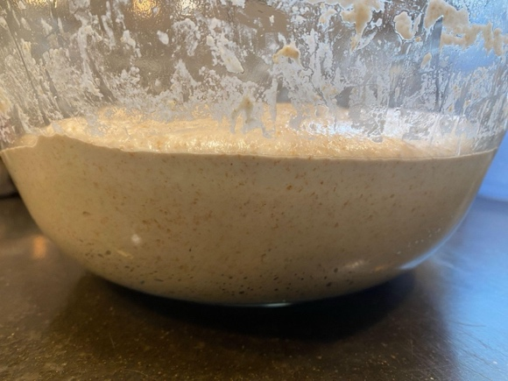

*Here is my dough after 4-5 hours. Its almost done. There are more bubbles and the dough feels much lighter and has bounce to it.*

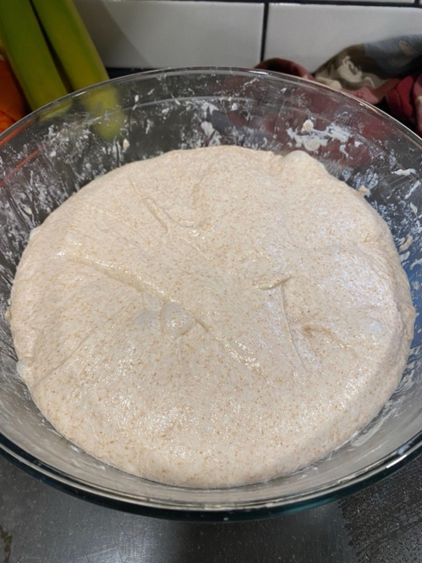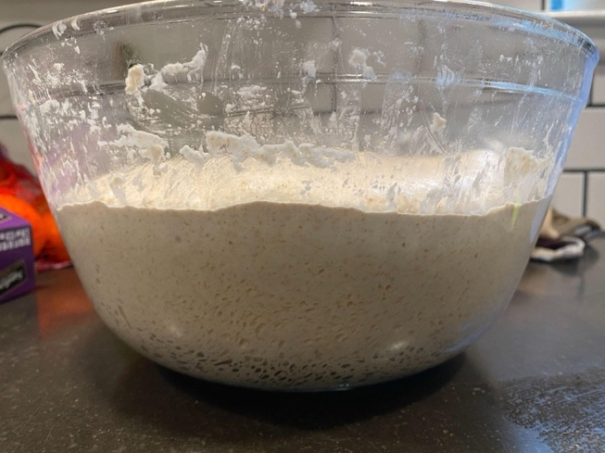

*This is the dough after 5-6 hours. Its done proofing! See the next step for what I look for to know the dough is ready.*

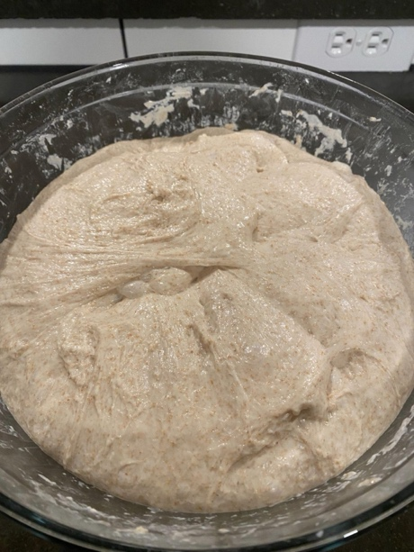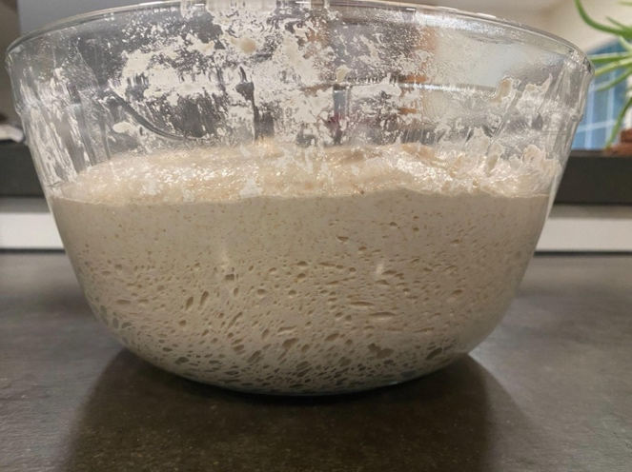

1. After 4-8 hours (depending on your kitchen temperature and strength of your starter) your dough will be done with bulk fermentation. This takes a bit of practice to know when the dough is done. The dough should have the following characteristics:
   1. At least double in size
   2. Have visible air bubles at the top of the dough
   3. If you are using a glass bowl (recommended), you should see lots of tiny bubbles on the side of the dough.
   4. When you jiggle the bowl, the dough should jiggle too. Think of the un-risen dough as cream and the risen dough as whipped cream!
2. However, be careful not to let your dough over proof. If this happens, the starter will have digested the gluten and your dough will be slack and messy and not be able to hold its shape. Experiment with your proofing time to find what works best for you. After rising, your dough should be able to hold its shape and while it will still be a little sticky, it shouldn’t be too sticky to be able to work with easily. Make a note of your proofing time and try altering this next time if you want to change the rise or texture of your final bread.

**Day 2 afternoon/evening: Shaping and preparing for cold fermentation**

1. Now that the dough is risen, you are ready to shape your loaves and prepare them for the cold proofing stage.
2. Gently pour your dough out onto a clean, unfloured surface, letting the weight of the dough coax it out of the bowl. Be careful to not squish the dough with your hands to keep all the air in the dough. Throughout this process, use as little of flour as you can. Too much flour will dry out your loaves and make it hard for the dough to stick to itself during folding and shaping.

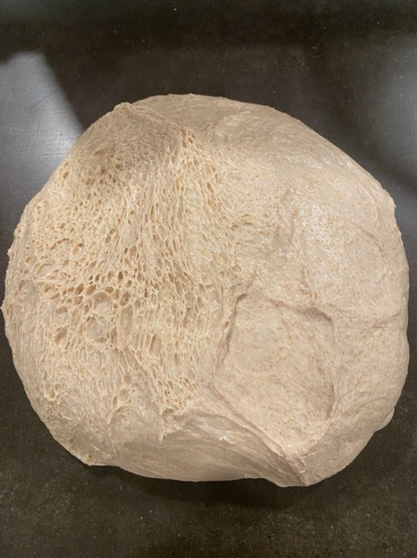

1. Using a pastry scraper, split the dough in half (here my halves were uneven - thats ok, you can vary the size of the loaves!)

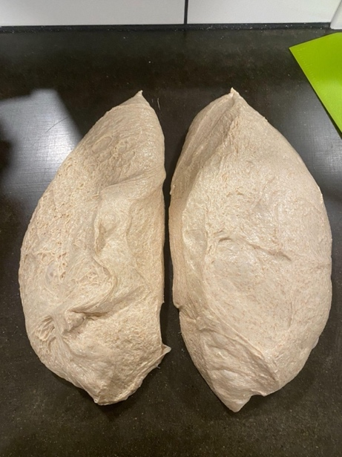

1. Add a dusting of flour to your counter and place one of the dough halves onto the flour.
2. Take a small handful of the dough and pull and attach it to the center. Work in a circle around the dough in 2-3 rotations to create a nice neat ball of dough.

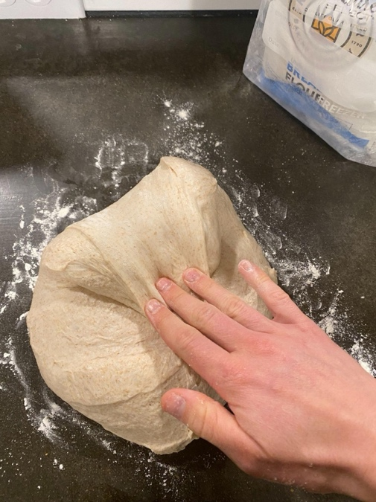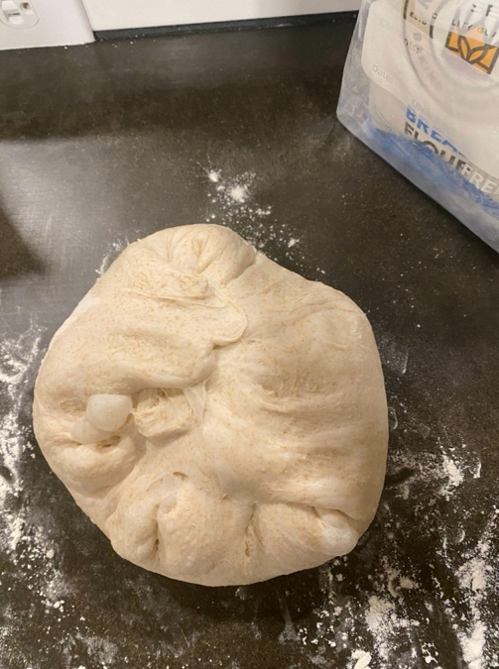

1. Using your scraper, invert the dough onto a lightly floured surface.

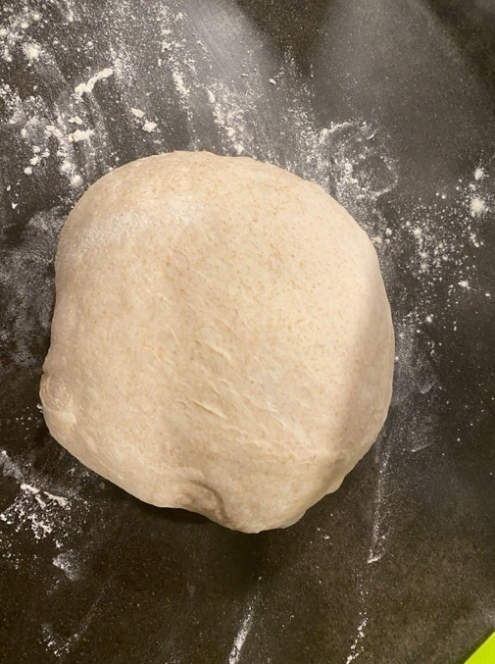

1. Repeat with the second half. Cover both balls of dough with a dry kitchen towel.
2. Let rest for 20-30 minutes. This is the preshaping step and will make your dough easier to shape into the loaves.
3. While this is resting, prepare your proofing baskets. Put the cloth covers in the baskets and give them a light dusting of rice flour.
4. After resting, take one of the dough balls and invert onto a lightly floured surface. Shape the dough.
   1. Gently stretch the dough into a rectangle-ish shape.

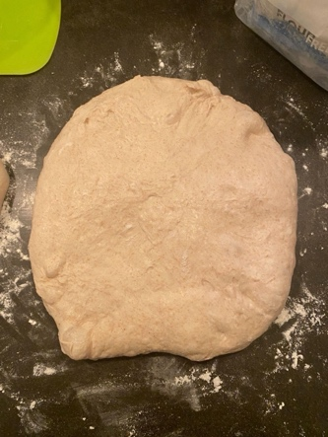

* 1. Take the bottom third of the dough and fold it upwards towards the middle. Gently tap or hold to let it attach to itself.

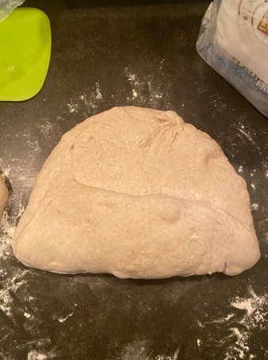

* 1. Then take the left side of the dough and fold it towards the middle.

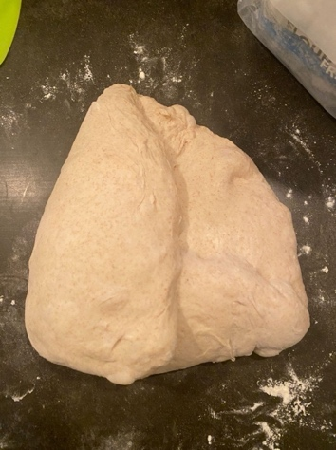

* 1. Repeat this process with the right side of the dough.

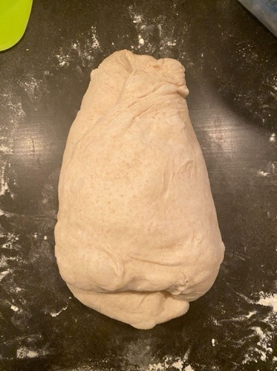

* 1. Take the remaining top portion of the dough and fold down into the middle. Hold until it secures in place.

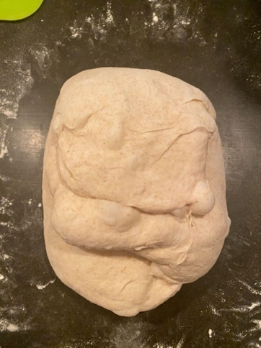

* 1. Next, perform “stitching”, which will create a nice tight package of dough and give the loaf structure. Take the two top corners of the dough, cross them over each other, and secure in the middle.

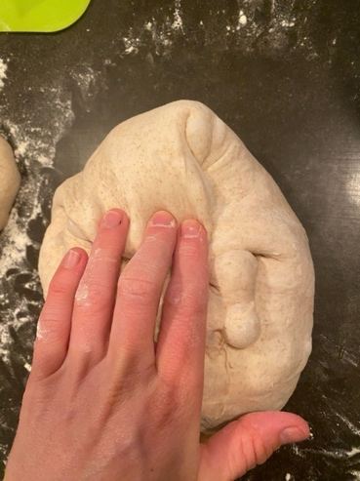

* 1. Then, work your way down the dough, taking the edges you create in the previous stitch and make 3-4 stitches down the dough.

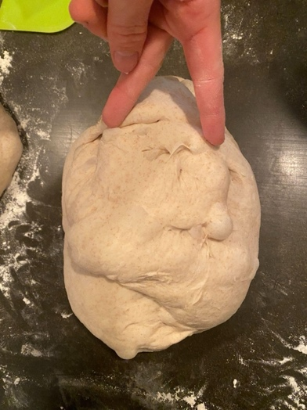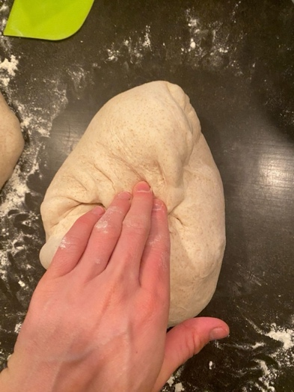

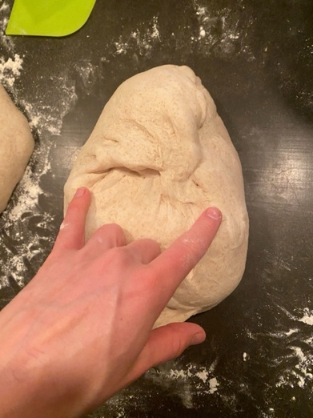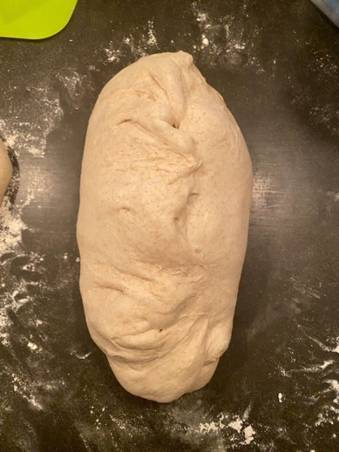

* 1. After the stitches are complete, roll the dough starting at the top and working your way to the bottom.

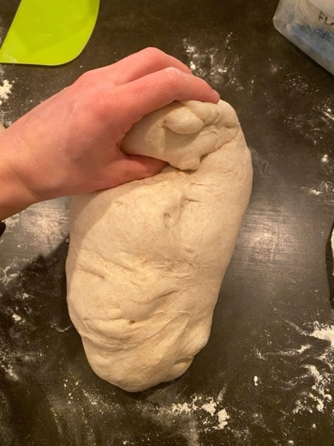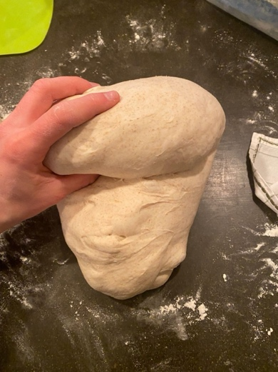

* 1. Let the dough sit upright to seal the bottom.
  2. Use your pastry scraper to tuck in the edges.

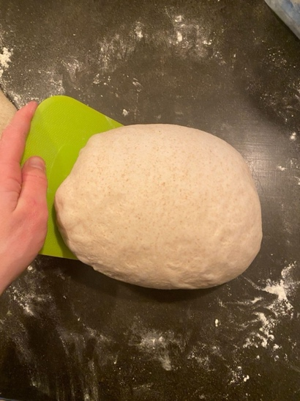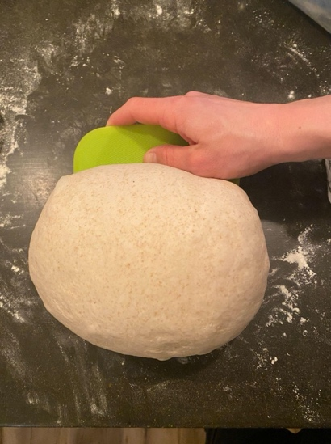

* 1. Use the scraper to now draw tension across the long side. This tension is what creates a nice ear and rise on your loaf in baking. Don’t put too much tension on the dough, just do a couple scrapes on each side to make it a nice tight package.
  2. Use the scraper to pick up and place the dough upside down (seam side up) in the proofing basket. You can gently pinch the bottom seam to seal it together. Lightly dust the loaf with some rice flour.

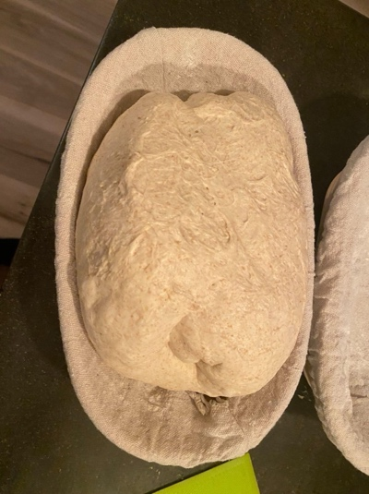

1. Repeat with the second half of the dough.
2. Once the loaves are in the proofing baskets, cover with a dry kitchen towel and let rise for another 20-30 minutes.
3. Now, cover with a plastic bread bag or lightly cover with plastic wrap and place in the fridge overnight.

**Day 3 morning: Bake!**

1. The next morning, preheat the oven to 500°F and place a cast iron dutch oven inside with the lid. Allow the oven and cast iron to preheat for at least 30 minutes before you bake the bread.
2. When you are ready to bake, remove one loaf from the fridge and remove the plastic wrap/bag.
3. Prepare a square of parchment paper and add cornmeal to the paper. Invert the loaf onto the parchment paper.

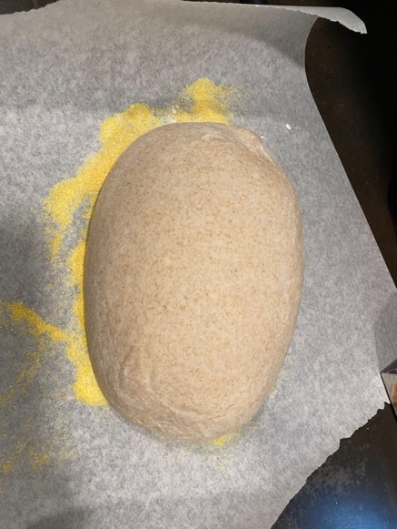

1. Use a kitchen brush to gently brush off excess flour.
2. If you want to add seeds to your loaf, spray with water using a water bottle sprayer.
3. Next, sprinkle poppy seeds or sesame seeds over your loaf. If you don’t want to use seeds, skip adding the water and seeds.

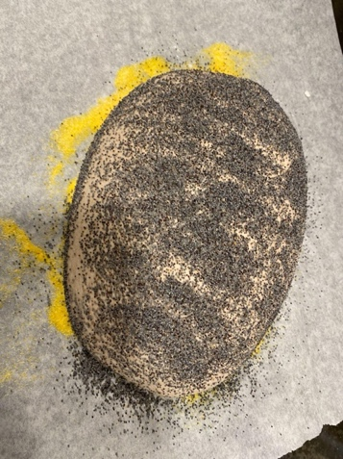

1. Score the dough using a bread lame. I like to make one slash across the loaf. Ensure the lame is scoring at least ¼” deep and with a shallow angle (~35°). This will give you a nice ear. If you score too vertically, the ear will not split. You can also try to add designs in your scoring.

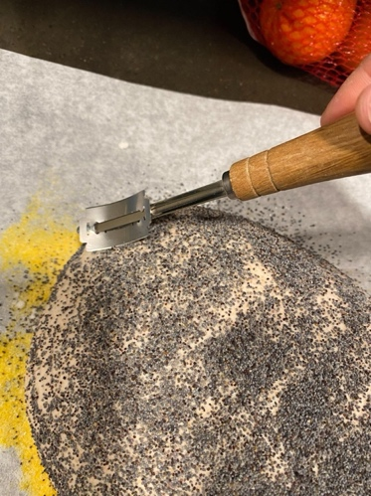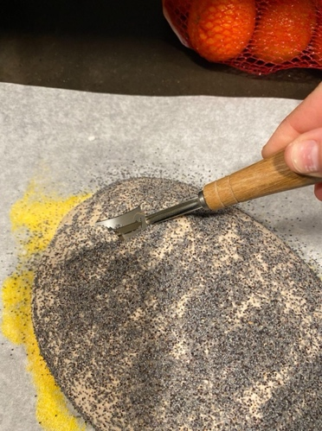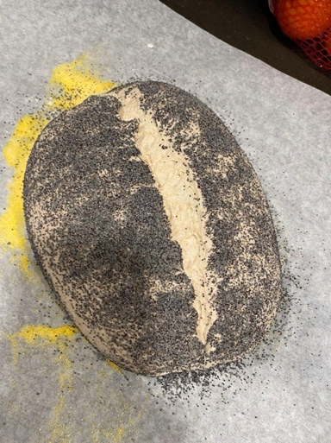

1. Take the cast iron out of the oven and place the bread with the parchment paper inside the pan.

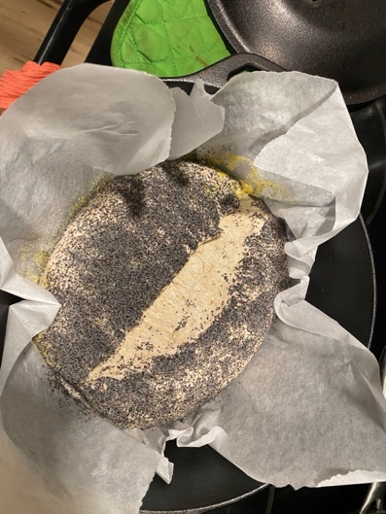

1. Close the lid.
2. Place in the oven.
3. Back for 20 minutes with the lid on.
4. After 20 minutes, remove the lid and turn the oven down to 450°F.

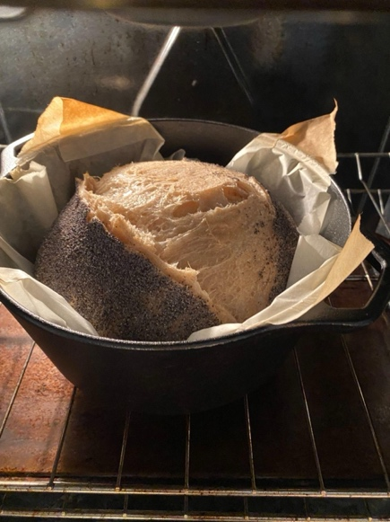

1. Bake for an additional 30-40 minutes. Bake until the crust is a deep golden brown. The bread will not dry out - ensure that you give it enough time to bake through and give you a nice dark crust!
2. Take the bread out and use the parchment paper to lift it onto a cooling rack.
3. Place the pan and the lid back in the oven and preheat again to 500°F for the next loaf.

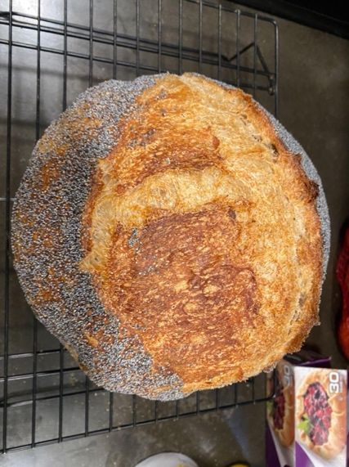 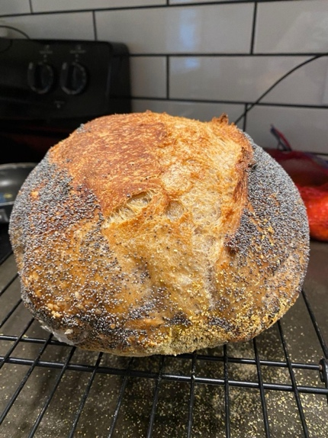

1. Repeat the baking process.
2. Ensure that you give the dough AT LEAST 2 hours to cool before cutting into it.
3. Slice and enjoy! I recommend slicing what you would like to eat over the next 2 days and keeping it in a bread pag or covered with a kitchen towel in a bowl. Slice the rest of the bread after baking and store it in a freezer bag in the freezer. After you use your fresh slices you will then have bread in the freezer ready to go. Just toast a frozen slice and it’ll taste as fresh as the first day!

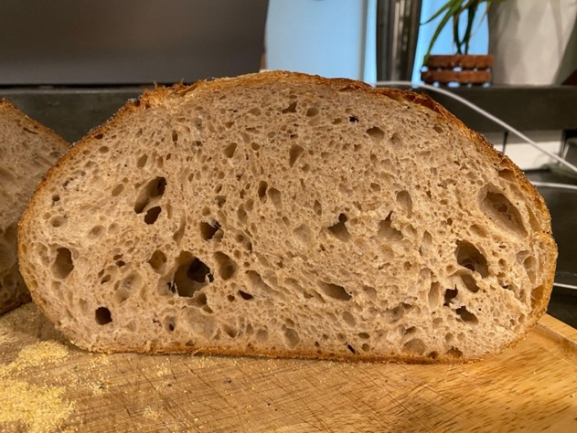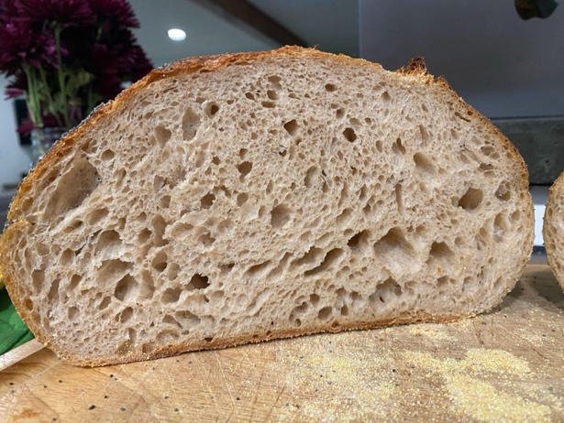

**Trouble shooting common problems**

Here are some problems I’ve had before - hopefully these notes can help!

*The bread is gummy and sticky when you cut into it.*

* You may have cut into the bread too early. Give the bread at least 2 hours to cool.
* The bread could also be over proofed. Next time try reducing the proofing time by 1-2 hours.

*The crust is too thick on the bottom.*

* Try adding a cookie sheet on another rack below the cast iron pan to reduce the crust on the bottom.

*The bread didn’t rise enough or make a nice ear in the oven.*

* There could be many reasons for this! Look at your technique for scoring - if the score is too vertical or too deep it may not create a nice ear. Score at a shallow angle about ¼” deep.
* You may try adding an hour or two to your proofing time to give it more rise.
* Make sure your oven and pan are super hot before baking your bread.
* If you aren’t baking in a dutch oven with a lid, you will not get much of a rise since the steam is allowed to escape. Try using a dutch oven with a lid.
* Make sure you are using a strong and healthy starter that is fully ready before adding to your dough.

*The bread isn’t sour enough.*

* Depending on the starter, you may need a longer cold proof to get more sourness. Try adding 4-6 hours to the cold proofing time. If you want less sour flavor, reduce the cold proofing time.

*The bread is too crumbly or too dense.*

* When you cut open your bread, you should see some large, irregular air pockets throughout the loaf. In between the big holes should be irregular small holes (see picture of my loaf above). No portion of the bread should be dense or without air holes. If you have large air holes between the crust and the bread this is an indicator that your bread is under proofed or that the starter wasn’t active.
* Double check your water and flour measurements to make sure the dough is hydrated.
* Try adding 1-2 hours of proofing time.
* Also take a look at your starter, if your starter isn’t active or strong enough, it may cause texture problems. Almost all sourdough problems have something to do with the starter or the proofing time!
* If you want even more open texture in your bread, you can experiment with adding 1-2% more water content. The bread will be harder to handle, but will bake with lighter texture!